Request for Proposal

Event Management Agency Partner for International Conference

Opening date: 9 October 2012 | Closing date: 17 October 2012

1. Summary of Requirements

The Network of Associations of Local Authorities of South East Europe (in the rest of the document referred to as “NALAS”) requests proposals from interested event management agencies for the provision of professional services to organize the venue of the International Conference "The Future of Fiscal Decentralization in South-East Europe", (in the rest of the document referred to as “Conference”) scheduled to take place in Hotel Splendid in Budva, Montenegro, on 1 and 2 November 2012.

2. Invitation

Event management agencies with proven experience and expertise in organization of high-level events are invited to respond to this request for proposal.

3. Request for Proposal Terminology

The following terms will apply to this Request for Proposal and to any subsequent Contract. Submission of a proposal in response to this Request for Proposal indicates acceptance of all the following terms:

Terminology
- “NALAS” means the Network of Associations of Local Authorities of South East Europe;
- “Contract” means the written agreement resulting from the Request for Proposal executed by the NALAS Secretariat and the successful company;
- “Contractor” means the successful company selected from this Request for Proposal;
- “Must”, “Mandatory” or “Required” means a requirement that must be met in order for a proposal to receive consideration;
- “Company” means an individual or a company that submits, or intends to submit, a proposal in response to this Request for Proposal.

4. Closing Date and Location

To be considered, proposals must be received electronically no later than 16:00 (CET),
Wednesday, 17 October 2012, at info@nalas.eu.

5. Enquiries

This Request for Proposal can be downloaded from the NALAS website at www.nalas.eu. Questions regarding this Request for Proposal should be directed to NALAS at +389 2 3090818, or by email to info@nalas.eu.

6. Ownership of Proposals

All documents, including proposals submitted in response to this Request for Proposal become the property of NALAS. However, only the submissions by the successful company will be used. Once a contract has been awarded, the name of the successful company will be available to the public upon request.

7. Project Overview

To further support the process of fiscal decentralization, NALAS, in partnership with the Ministry of Finance of Montenegro and the Union of Municipalities of Montenegro organizes the Regional Conference: The Future of Fiscal Decentralization in South-East Europe, from 1-2 November 2012, in Budva, Montenegro.

The conference aims to discuss, strategize and develop a deeper understanding of the challenges and opportunities facing the Region in finding the right ways to finance projects and activities of sustainable local development. It will provide a space for a dialogue between the Ministries of Finance and the Associations of Local Authorities on local government financial needs.

The conference will gather around 100 participants, including: Ministries of Finance, Mayors, Local Government, Associations, Municipal Finance Analysts, Researchers, CEOs, Economists, Policy Regulators, Financial Controllers, Infrastructure Managers, etc.

The conference will be highly interactive, with presentations and discussions that will reflect the best practices, but also joint challenges and opportunities facing the Region in providing sustainable financing of competencies of the local governments.

8. Project Scope and Objectives

The primary objectives that form the basis of this Request for Proposal are:

- Conference Venue Branding

Objective: Provide appropriate visual identity of the conference venue.

Scope: Based on the venue setting plan provided by NALAS (photo 1 is sitting arrangement suitable for day 1 and photo 2 is the table setting suitable for day 2 of the Conference), the contractor will propose a plan for visual identity of the conference venue, and will implement it, including: banners (and their organization in the space), NALAS flag, flower arrangements, etc. NALAS will provide design solutions for the banners.

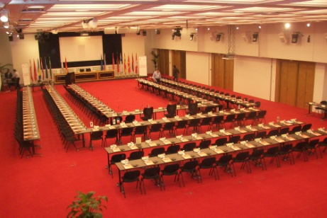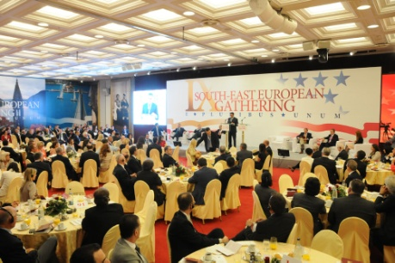

The end deliverables will include an implemented plan for visual identity of the Conference Venue.

- Camera and photography

Objective: Provide video and photography record of the Conference.

Scope: The contractor will provide a video camera, microphone and a professional cameraman for recording the Conference and conducting interviews with participants (interview content will be managed by NALAS Knowledge and Communications Manager). Also, the contractor will provide a photo camera and a professional photographer for the whole duration of the Conference.

The end deliverables will include: a CD with the complete video material from the conference and interviews and a CD with all the photos from the conference.

9. Proposal submission

The following format and sequence should be followed in order to provide consistency in Company response and to ensure each proposal receives full and fair consideration. All pages should be consecutively numbered.
- Cover Page, showing the name of the event management agency, address and contact information;
- One page letter of introduction, signed by an authorized signatory;
- Table of Contents, including page numbers;
- A short summary of the key features of the proposal;
- The body of the proposal, including proposed solutions for the conference venue, suggestions, recommendations, the budget and services;
- Any additional information such as references and components listed under the mandatory and desirable criteria, not included in the body of the document.

10. Evaluation

Evaluation of proposals will be undertaken by NALAS Evaluation Committee. At the sole discretion of the Committee, a short list of the highest scored companies will be developed. Companies on the short list may be invited to further clarify their offers. After the presentation(s), the Committee will re-evaluate the short-listed proposals and bring the final decision.

11. Criteria

The proposals will be evaluated and rated based on the criteria set out in this Request for Proposal document.
- Proposals must be in English, and the Proposal must be submitted by the appropriate date and time;
- Proposals must clearly list, in detail, what services will be provided.
- Responses must contain a list of references of past projects and work of this nature, with contact names and telephone numbers.

12. Scoring

- 20% Creativity and Familiarity – include a description of your view of the conference.
- 30% Innovation in Approach - Methodology – a work plan including the proposed method to accomplish the tasks identified in the Request for Proposal.
- 10% Previous Experience in undertaking similar work - indicate the number of projects of similar professional services and type or the number of projects of similar scale. Demonstration of willingness to be flexible in working with NALAS.
- 30% Cost and Ability to Meet Deadlines - Provide project quote, , and a detailed explanation of the deliverables and services you will provide to NALAS.
- 10% References - Provide references from previous clients including specific contacts and phone numbers.

13. Modification of Terms

NALAS reserves the right to modify the terms of the Request for Proposal at any time at its sole discretion.

14. Company Expenses

Companies are solely responsible for their own expenses in preparing a proposal and for subsequent negotiations with NALAS. Short-listed proposals may be asked to make a presentation to the Evaluation Committee, which will be solely at the Company's own expense.

15. Acceptance and Rejection of Proposals

NALAS may not necessarily accept the lowest priced proposal or any proposal. At its sole discretion, NALAS reserves the right to reject any or all proposals received and to accept any proposal which it considers advantageous, whether or not it is the lowest priced proposal. NALAS is not under any obligation to award a contract, and reserves the right to terminate the Request for Proposal process at any time, and to withdraw from discussions with all or any of the Companies who have responded. NALAS reserves the right to accept the proposed offer in total or in part, to reject any or all offers, to waive any minor informalities, irregularities, or technicalities, and to accept the offer deemed most favourable to the Network.

16. Contract Negotiation

NALAS reserves the right to negotiate specific terms of the contract with the short-listed proponents prior to the final award of the contract. NALAS also reserves the right to negotiate specific terms of the contract with the Contractor as the contract progresses.

Thank you for your interest in submitting a proposal. It is hoped that the information provided is of value and should anything be unclear, please contact NALAS directly.

