**header za vo word_1**

*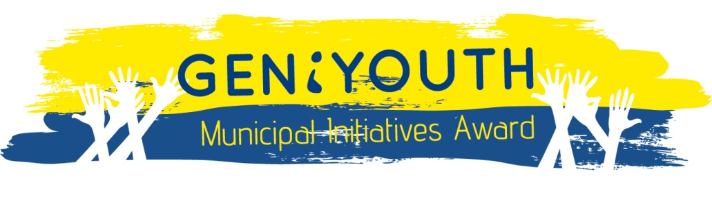*

***OPEN CALL for GOOD PRACTICES***

***GENiYOUTH Municipal Initiatives 2014:***

***APPLICATION FORM***

*\_\_\_\_\_\_\_\_\_\_\_\_\_\_\_\_\_\_\_\_\_\_\_\_\_\_\_\_\_\_\_\_\_\_\_\_\_\_\_\_\_\_\_\_\_\_\_\_\_\_\_\_\_\_\_\_\_\_\_\_\_\_\_\_\_\_\_\_\_\_\_\_\_\_\_\_\_\_\_\_\_\_\_\_\_\_\_\_\_\_\_\_\_*

*Collection and Documentation of Good Practices*

***GENiYOUTH Municipal Initiatives*** - ***Inclusion of Women and Youth in Local Government Affairs in South East Europe***

***Key Notes:***

* Please use the template below to submit the good practice. Please be as brief and relevant as possible in responding to each part.
* Please write directly in the text boxes below and follow the short guidelines (in red colour) that will help you fill in the form successfully.
* Please refer to the Open Call for details regarding the eligibility and selection criteria.
* Attach only the documents which are absolutely essential for sharing additional information.
* The proposals should be submitted in English, to the NALAS Secretariat at: **geniyouth@nalas.eu**
* The deadline for the submission is **19 December 2014.**
* During the application review process, applicants may be contacted to provide additional clarifications and to discuss some aspects of their applications, if necessary.

***General information***

|  |  |
| --- | --- |
| **Title of the Good Practice** | What is the name that best describes the good practice? Should be short and specific. Use keywords. |
| **Location/Geographical coverage** | Where the good practice has been implemented and/or used? Please specify the country, region, town, when possible. |
| **Implementing institution/organization** | State the full name of the organization, as given in the Registration Certificate. |
| **Contact person** | State the full name, surname and position of the contact person in charge for the application. |
| **Contact details** | Provide the contact details of the institution (office number, address, email, and website) and the contact details of the contact person (email, phone number). |
| **Good Practice Theme/Key words** | Categorize the good practice according to the thematic areas described in the Open Call |
| **Date of submission** | State the date of submission of this application form. |

***Background and rationale (max half page)***

|  |
| --- |
| What is the context (initial situation) and challenge being addressed? Provide the problem statement, action justification, connection with specific local policy on gender or youth. Explain/elaborate the problem or issue that your good practice has addressed. Be sure to include the brief history of the need/problem and explain why you have chosen to address this need/problem. (max half a page) |

***Good practice description – the success story… (max 3 pages)***

|  |
| --- |
| *Make sure that you provide answers to the main Questions: What? Why? How? Who? When? The description should provide answers to the following questions:*   * *What was the main* ***objective*** *of the action?* * *What has been done? What were the main* ***activities and steps*** *that were undertaken?* * *What kind of* ***approaches, methods, and tools*** *were used? Please provide insight into the methodological approach.* * *Who were the* ***target groups*** *and* ***direct beneficiaries****? Who are the users of the good practice?* * *Who were the* ***institutions, partners and donors involved*** *and what was the nature of their involvement?* * *What were the measurable* ***results (outputs and outcomes)*** *of your practise? What are the tangible products?* * *What has been the* ***impact*** *on the final beneficiaries? What are the* ***visible changes*** *that were accomplished? You may conclude this description by specifying the impact and usefulness of the good practice. When possible, use anecdotal evidence, storytelling or testimony, showing the benefits.*   *(max 3 pages)* |

***Your personal assessment***

|  |
| --- |
| ***Constraints and lessons learned***  *What were the main challenges and difficulties encountered? How have they been addressed and overcome?*  *What are the key messages and lessons learnt to take away from the good practice experience? (max half a page)* |

|  |
| --- |
| ***Innovations and critical success factors***  *Explain the innovation/s:In what way has the good practice contributed to an innovation in the livelihoods of men, women and/or youth? What can be taken as innovative and unique?*  *Why this practice was a success? What can be considered as a ‘”selling point” when it comes to replication and scaling up of this practice? What are the possibilities of extending the good practice more widely?*  *(maximum half a page)* |

|  |
| --- |
| ***Validation***  *Are there are confirmations and testimonies by the beneficiaries that the practice address the needs properly? Could you briefly list and describe them, and provide the originals in an Annex? (maximum one page)* |

|  |
| --- |
| ***Sustainability***  *What are the elements that are put into place and make the good practice sustainable? (maximum half a page)* |

***Annexes:***

|  |
| --- |
| 1. One-page summary of the Good Practice (obligatory) 2. Validation documents (obligatory) 3. Concrete visibility products, if any (publications, manuals, tools, video and audio documents, etc…) |